Standard Cell Potentials
FlexBooks® 2.0 > CK-12 Chemistry For High School > 23.7 Calculating Standard Cell Potentials
Standard Hydrogen Electrode
The activity series allows us to predict the relative reactivity of different materials when used in oxidation-reduction processes. We also know we can create electric current by a combination of chemical processes. By combining these two ideas… How can we predict the expected amount of current that will flow through a redox system? We measure the force “pushing” the flow of electrons as voltage (an electromotive force or potential difference, in volts) and the amount of electrons flowing as electrical current (in amps). In REDOX chemistry, the nature of the oxidising agent and the reducing agent primarily determines the cell voltage. If the oxidising agent and the reducing agent are a long way apart in the activity series we would expect a high “push” for electron exchange and therefore, a high voltage to be produced when the electrons are exchanged.
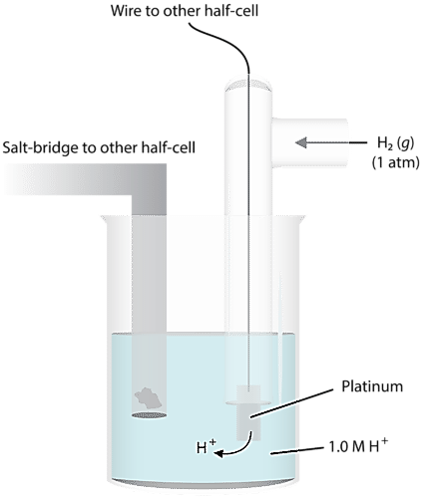
to create a system to quantify this, we need some way of numerically comparing the extent of electron flow in the various chemical systems. The best way to do this is to have a baseline that we use… a standard that everything can be measured against. For determination of half-reaction current flows and voltages, we use the standard hydrogen electrode – shown in figure one. A platinum wire conducts the electricity through the circuit. The wire is immersed in a 1.0 M strong acid solution and H₂ gas is bubbled in at a pressure of one atmosphere and a temperature of 25°C. The half-reaction at this electrode is:
Figure 1 – Standard H⁺|H₂ electrode
H₂ → 2H⁺ + 2e⁻.
Under these conditions, the potential for the hydrogen reduction is defined as exactly zero. We call this value the standard reduction potential, or E⁰.
We can then use this system to measure the standard reduction potentials of other electrodes in the half-cell. A metal and one of its salts (sulfate is often used) is in the second half-cell. We will use zinc as our example (see Figure 2 below).
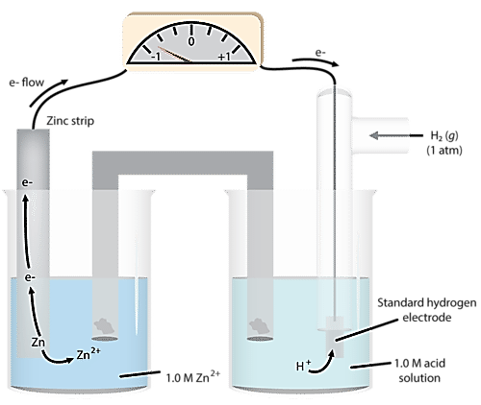
Figure 2:
Figure 2 shows the standard hydrogen half-cell paired with a zinc half-cell. As we observe the reaction, we notice that the mass of solid zinc in the zinc half-cell decreases during the course of the reaction. This suggests that Zinc metal is being oxidised, and correspondingly this means that reduction is occurring in the hydrogen half-cell
So, we have the following process occurring in the cell:
Zn_{(s)} → Zn²⁺_{(aq)} + 2e⁻ (anode−oxidation)
2H⁺ + 2e⁻ → H₂ (cathode−reduction)
The measured cell voltage is 0.76 volts.
We define the standard EMF (electromotive force) of the cell as the difference between their standard reduction potentials:
E⁰cell = E⁰_{reduction ½ reaction} − E⁰_{oxidation ½ reaction} This sometimes summarised as E⁰ = E⁰_{red} − E⁰_{ox}
0.76 v = 0 - E⁰_{Zn}
E⁰_{Zn} = -0.76 v
Thus the standard reduction potential of Zn⁺²|Zn half-cell is -0.76v
By comparing a series of half-cells to the hydrogen half-cell, a table of standard reduction potentials for all the half-cells can be constructed (see next page).

Review

- What is the defined potential of the hydrogen electrode?
- What is the chemical composition of this electrode?
- What are the standard conditions for the half-cell?

Calculating Standard Cell Potentials
Standard electrode potentials at 298 K
Oxidised species ⇌ Reduced species | E^{O}  (v)
Li⁺_{(aq)} + e⁻ ⇌ Li_{(s)} | −3.04
K⁺_{(aq)} + e⁻ ⇌ K_{(s)} | −2.94
Ba²⁺_{(aq)} + 2e⁻ ⇌ Ba_{(s)} | −2.91
Ca²⁺_{(aq)} + 2e⁻ ⇌ Ca_{(s)} | −2.87
Na⁺_{(aq)} + e⁻ ⇌ Na_{(s)} | −2.71
Mg²⁺_{(aq)} + 2e⁻ ⇌ Mg_{(s)} | −2.36
Al³⁺_{(aq)} + 3e⁻ ⇌ Al_{(s)} | −1.68
Mn²⁺_{(aq)} + 2e⁻ ⇌ Mn_{(s)} | −1.18
2H₂O_{(l)} + 2e⁻ ⇌ H_{2(g)} + 2OH⁻_{(aq)} | −0.83
Zn²⁺_{(aq)} + 2e⁻ ⇌ Zn_{(s)} | −0.76
Fe²⁺_{(aq)} + 2e⁻ ⇌ Fe_{(s)} | −0.44
Ni²⁺_{(aq)} + 2e⁻ ⇌ Ni_{(s)} | −0.24
Sn²⁺_{(aq)} + 2e⁻ ⇌ Sn_{(s)} | −0.14
Pb²⁺_{(aq)} + 2e⁻ ⇌ Pb_{(s)} | −0.13
2H⁺_{(aq)} + 2e⁻ ⇌ H_{2(g)} | 0.00
Cu²⁺_{(aq)} + e⁻ ⇌ Cu⁺_{(aq)} | +0.16
SO ₄ ² ⁻_{(aq)} + 4H⁺_{(aq)} + 2e⁻ ⇌ SO_{2(aq)} + 2H₂O_{(l)} | +0.16
Cu²⁺_{(aq)} + 2e⁻ ⇌ Cu_{(s)} | +0.34
O_{2(g)} + 2H₂O_{(l)} + 4e⁻ ⇌ 4OH⁻_{(aq)} | +0.40
Cu⁺_{(aq)} + e⁻ ⇌ Cu_{(s)} | +0.52
I_{2 (s)} + 2e⁻ ⇌ 2I⁻_{(aq)} | +0.54
Fe³⁺_{(aq)} + e⁻ ⇌ Fe²⁺_{(aq)} | +0.77
Ag⁺_{(aq)} + e⁻ ⇌ Ag_{(s)} | +0.80
Br_{2(l)} + 2e⁻ ⇌ 2Br⁻_{(aq)} | +1.08
O_{2(g)} + 4H⁺_{(aq)} + 4e⁻ ⇌ 2H₂O_{(l)} | +1.23
Cl_{2(g)} + 2e⁻ ⇌ 2Cl⁻_{(aq)} | +1.36
Cr₂O ₇² ⁻_{(aq)} + 14H⁺_{(aq)} + 6e⁻ ⇌ 2Cr³⁺_{(aq)} + 7H₂O_{(l)} | +1.36
MnO⁻_{4 (aq)} + 8H⁺_{(aq)} + 5e⁻ ⇌ Mn²⁺_{(aq)} + 4H₂O_{(l)} | +1.51
F₂(g) + 2e⁻ ⇌ 2F⁻_{(aq)} | +2.89

In order to react and transfer electrons, any electrochemical cell must consist of two half-cells, one in which oxidation occurs and one in which reduction occurs. The table of standard reduction potentials can be used to determine the reactions that will occur in each half-cell, and the standard cell potential for any combination of two half-cells, without actually constructing the cell.
The half-cell with the most positive reduction potential according to the table will undergo reduction. For this cell, the half reaction that occurs is the reduction half-reaction – the left to right version in the table of standard reduction potentials.
The half-cell with the least positive reduction potential will undergo oxidation within the cell. For this half-cell, the reaction that occurs will be the oxidation half-reaction - the right to left version seen in the table of standard reduction potentials.
If those specifications are followed, the overall cell potential will be a positive value for a galvanic cell, indicating the overall REDOX reaction is spontaneous. The cell potential must be positive in order for redox reaction of the cell to be spontaneous. If a negative cell potential were the result of any combination of half-cells, that REDOX reaction would NOT be spontaneous in the forward direction (left to right). Another way of saying this is that a redox reaction with a negative E⁰ is spontaneous in the reverse direction (right to left)

Sample Problem: Calculating Standard Cell Potentials
- Calculate the standard cell potential of a voltaic cell that uses an Ag electrode in a Ag⁺ solution and a Sn electrode in a Sn²⁺ solution.
- Write the balanced equation for the overall cell reaction that occurs.
- Identify the anode and the cathode.
Step 1: List the known values and plan the problem.
Known (from E⁰ table)

- E⁰_{Ag} = +0.80 v
- E⁰_{Sn} = −0.14
- E⁰ = E⁰_{red} − E
Unknown
- E⁰_{cell} = ? v
The silver half-cell will undergo reduction because its standard reduction potential is the most positive. The tin half-cell will undergo oxidation, as it is the least positive E⁰. The overall cell potential can be calculated by using the equation E⁰ = E⁰_{red} − E⁰_{ox}.
Step 2: Solve.
oxidation (anode): Sn_{(s)} → Sn²⁺_{(aq)} + 2e⁻
reduction (cathode): Ag⁺_{(aq)} + e⁻ → Ag_{(s)}
Before adding the two reactions together, the number of electrons lost in the oxidation must equal the number of electrons gained in the reduction. The silver half-cell reaction must be multiplied by two. After doing that and adding to the tin half-cell reaction, the overall equation is obtained.
overall equation Sn_{(s)} + 2Ag⁺_{(aq)} → Sn²⁺_{(aq)} + 2Ag_{(s)}
The cell potential is calculated.
E⁰ = E⁰_{red} − E⁰_{ox} = +0.80 v − (−0.14 V) = +0.94 v
Step 3: Think about your result.
The standard cell potential is positive, so the reaction is spontaneous as written. Tin metal is oxidized at the anode, while silver ions are reduced at the cathode. Note that the voltage for the silver ion reduction is not doubled even though the reduction half-reaction had to be doubled to balance the overall redox equation.
Oxidizing and Reducing Agents
Any substance that is capable of being reduced easily is a strong oxidizing agent. Conversely, any substance that is capable of being oxidized easily is a strong reducing agent. According to the standard cell potential table, fluorine (F₂) is the strongest oxidizing agent in the list of oxidising agents (species listed on the left hand side of the reaction arrows). It will oxidize any substance above it (and on the right hand side) on the table. For example, fluorine (lowest on the left) will oxidize silver metal (higher and on the right) according to the following reaction.
F_{2(g)} + 2Ag_{(s)} → F⁻_{(aq)} + 2Ag¹⁺_{(aq)}
Lithium metal (Li_{(s)}) is the strongest reducing agent listed in the table (highest on the right). It is capable of reducing any substance below it (and on the left) on the table. For example, lithium metal will reduce water according to this reaction (combination of both half reactions).
2Li_{(s)} + 2H₂O_{(l)} → 2Li⁺_{(aq)} + 2OH⁻_{(aq)} + H_{2(g)}
Using the table above will allow you to predict whether reactions will occur or not. For example, nickel metal is capable of reducing copper (II) ions, but is not capable of reducing zinc ions. This is because nickel metal (Ni_{(s)}) is above Cu²⁺, but is below Zn²⁺ in the table. As an example of this… Which of the following solutions would react with a container made from copper metal if the container was used to store the solution?

- ZnSO₄ solution (1 M)
- AgNO₃ solution (1 M)
- PbI₂ soltuion (1 M)
- HNO₃ (1 M
Your teacher will give you some questions to practice, but they will all be variations of these two common themes- calculating voltage for a given galvanic cell, or predicting whether a reaction is spontaneous.

